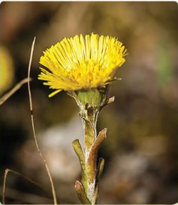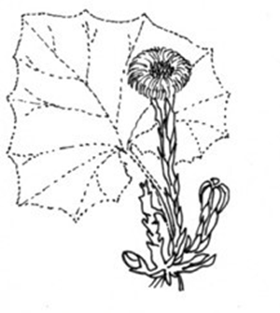
PODBĚL LÉKAŘSKÝ
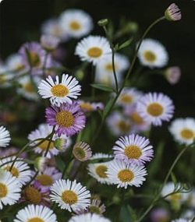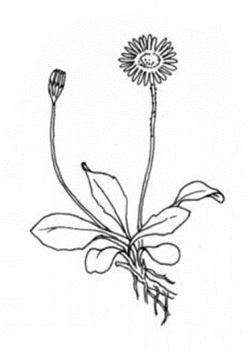
SEDMIKRÁSKA CHUDOBKA

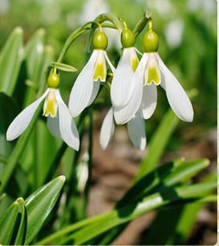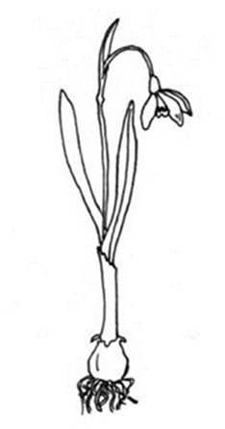
SNĚŽENKA PODSNĚŽNÍK

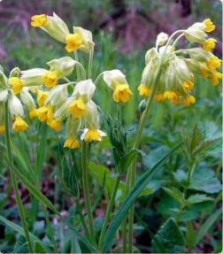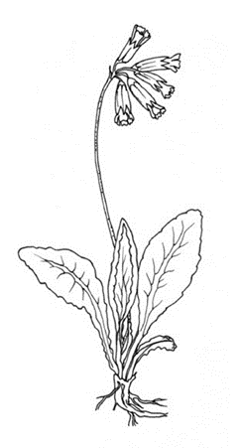
PRVOSENKA JARNÍ

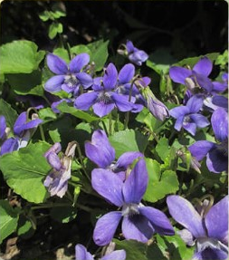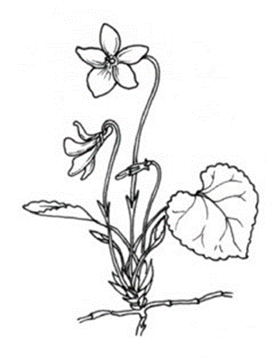
VIOLKA VONNÁ (FIALKA)

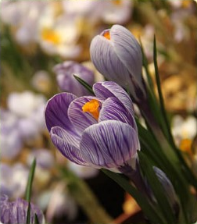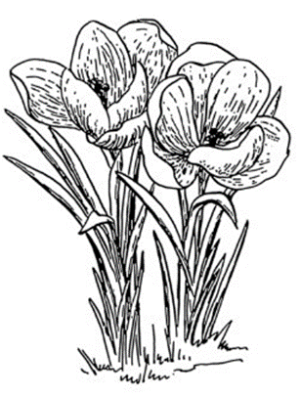
ŠAFRÁN ZAHRADNÍ (KROKUS)

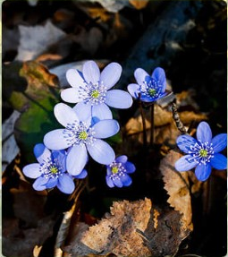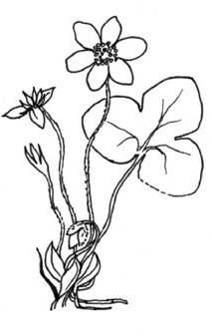
JATERNÍK PODLÉŠKA

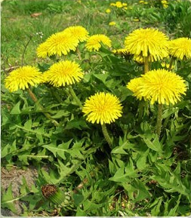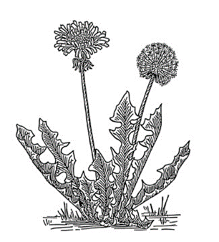
PAMPELIŠKA LÉKAŘSKÁ

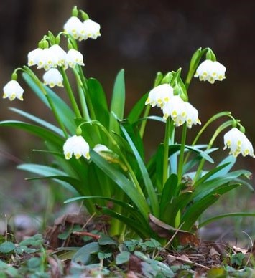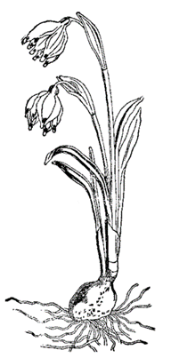
BLEDULE JARNÍ

Zdroje fotografií a obrázků:
https://interaktivita.etaktik.cz/book/18.1
https://prima-receptar.cz/wp-content/uploads/2014/03/bledule-jarni.jpg
https://ucimesevenku.cz/wp-content/uploads/2018/03/PL-JARNI-KVETY.pdf
https://wiki.rvp.cz/index.php?title=Kabinet/0.0.0.Kliparty/Kv%C4%9Btiny/Jarn%C3%AD_kv%C4%9Btiny_-_%C4%8Dernob%C3%ADl%C3%A9_obr%C3%A1zky_(smetanka%2C_tulip%C3%A1n%2C_krokus%2C_sn%C4%9B%C5%BEenka%2C_bledule%2C_mod%C5%99enec%2C_narcis%2C_konvalinka%2C_violka%2C_kopretina%2C_mace%C5%A1ka%2C_...)

